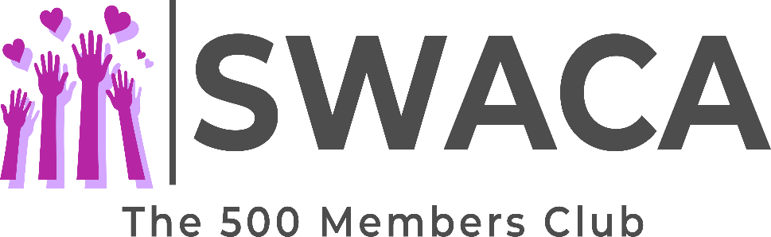

Membership Application Form
YOUR CHANCE TO WIN A CASH PRIZE EVERY MONTH
Name
Address:
Email:
Tel No:
State number of shares per month @ £5 each
Total Monthly Payment
Membership Start Date
Please insert the date you would like your membership to begin!
Please tick box:
I confirm I am 16 years of age or over:
I confirm that I have read and agree to the Terms and Conditions:
Signed: |  | Date:
Method of payment:
- Set up monthly standing order with your bank:

You will be entered into the draw of the month from which the first payment is received.
The draw will be conducted at the end of every month.
Standing order details:
Account Name: Sefton Women’s and Children’s Aid
Sort Code: 60-09-13
Account Number: 97663581

*Please note that we cannot accept monthly cash/cheque payment for this scheme*

Please complete and return to: fundraising@swaca.com

Office Use:
No. of Shares per month Numbers Allocated:
Added to Database & Notified: YES/NO Date Form Received

